**Compass (Real Estate)**

**Recommendation:** Compass is valued with the multiples of a tech company, but behaves a lot like a traditional brokerage enhanced with technology. Compass is burning through cash to acquire agents, through broker acquisitions and traditional incentives, with SoftBank footing the bill, but their strategy is “not ... sustainable nor unique; it’s possible for others to copy”. Compass cannot justify this valuation as a traditional real estate brokerage. To achieve a meaningful outcome for owners and investors, Compass needs to embrace more radical changes to its business model.

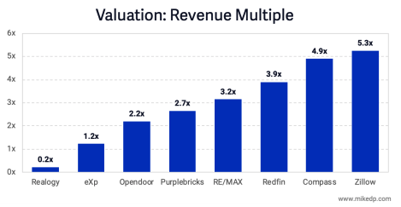

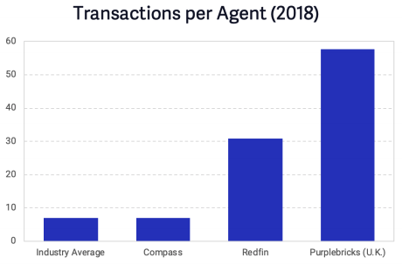

The company will have an IPO and I think the same thing that happened to WeWork will happen here: the public will realize their valuation is not appropriate because their current model is not sustainable in the long run. **At a 91% LRPP share price, you only have a 9% buffer before taking a loss, but I believe the valuation will go lower than that.**

**Opportunity:** Acquire a forward contract on 6,647 shares under option from Chuck Canton, Compass’ Head of Financial Services and Operations from July 2018 to July 2020, and a forward contract on 736 shares under option from Rodrigo Hernandez, IT Manager since January 2018 and with the company since December 2014. Chuck is launching a new venture in January and is pouring all available personal capital into that. Rodrigo Hernandez is planning to take a new job imminently and has a 90 day window from his move to make sure his equity does not disappear.

Purchase price per share of $140.39, a 9% discount to the preferred price per share of $154.27 (per Pitchbook).

If we do not acquire Chuck’s contract, Dave estimates Rodrigo will sell for 50% LRPP (ie. $77.13 per share).

Compass’ latest round of financing was a $500M Series G closed in November 2019 at a $6B pre-money and $6.5B post-money valuation. The investors who participated in the round were: Alumni Ventures Group, Asland Capital Partners, Canada Pension Plan Investment Board, Dragoneer Investment Group, Qatar Investment Authority, SoftBank Group, and SoftBank Investment Advisers.

Previous Rounds:

| **Deal Type** | **Date** | **Amount** | **Pre-Val** | **Post-Val** |
| --- | --- | --- | --- | --- |
| Series F | September 2018 | $400M | $4B | $4.4B |
| Series E | December 2017 | $550M | $1.7B | $2.2B |
| Series D | August 2016 | $90M | $925M | $1.02B |
| Series C | September 2015 | $60M | $750M | $810M |
| Series B | July 2014 | $42M | $320M | $362M |
| Series A | September 2013 | $33.24M | $100M | $133.24M |
| Seed Round | January 2012 | $8M | Unknown | Unknown |

**Background:** Founded in 2012 in New York City, New York. Raised $1.61B to date. ~500 full-time employees and ~17,000 agents.

**Summary:** Compass is an online brokerage firm for buying and selling real estate properties. The company assists the buyer throughout the process of owning a property from discovering properties to sealing the deal, along with the paper works. Users can browse listings and schedule viewings via the app. Its mobile app is available for Android and iOS devices. Compass employs more than 15,000 agents who earn a percentage of the selling price and give 15 to 30 percent on each sale to Compass

**Pain Point:** The process of buying and selling a home can be costly and time-consuming. Compass makes it more easy and streamlined by providing their brokers with tools to find listings, preparing presentations and more.

**Product**: Web platform for viewing homes for sale in the market and for listing sales. It shows a virtual tour, location, property history, schools nearby, an analysis of the neighbourhood and homes similar to the ones you are watching. Compass Concierge is a service that helps you sell your home faster and for more money by covering the cost of home improvement services with no upfront fees or interest charged. Compass also has a tool to increase the productivity of agents by aiding them both in the buying and selling process through the use of technology

**Market**: 6,000,000 houses (yearly volume) * $230,000 (median price) * 6% (usual commission) = **$82.8B**

**Competition**:

1. Brokerages:
   1. Trulia (Owned by Zillow Group)
      1. THey have their own tool which attempts to break down the real cost of purchasing a home into more digestible monthly payments.
      2. Best feature is the map that displays information about a home’s surrounding area, including recent sales, local schools, crime rate, public transportation options and many more.
   2. Redfin
      1. Redfin agents charge 4.5% commission.
      2. Provides home value estimates with a margin of error of 1.77% for on-market homes and 6.66% for off-market.
      3. Agents are employees paid a fixed salary and do not earn a commission, instead they receive bonuses based on their customer reviews.
   3. Purplebricks
      1. They are from the UK
      2. Much more efficient. Each of their agents perform almost ten times the amount of transactions than Compass’ ones.
2. Pure tech companies:
   1. Zillow
      1. Has online listings for thousands of homes.
      2. Has the ability to find agents who charge 6% commission in your area.
      3. Downside is that their home-pricing AI is a bit off, as well as their cost of living estimates, which feed off the previous data.
      4. They have moved into the iBuyer space and do arbitraging.

**Differentiation/Defensibility**: They are currently not very differentiated. They may use more technology than “traditional” brokers, but for the most part they work like them. Their main form of growth is through acquisitions, which are not differentiated at all, they just require capital.

**Team**: ~500 full-time employees in 2020. 17,000+ real estate agents. Founding team:

1. Robert Reffkin(Co-Founder & CEO)
   1. Ex-Goldman Sachs, The White House, Lazard, McKinsey & Company. Columbia University in the City of New York BA 1999, Columbia University - Columbia Business School MBA 2003.
2. Ugo Di Girolamo (Co-Founder)
   1. Ex-Twitter, Co-Founder Julpan, Google, GE Security. Sapienza University of Rome MS 1998.
3. Eric Prigot (Co-Founder)
   1. Ex-TripleMint, The Corcoran Group. Virginia Tech BS 2003, Virginia Polytechnic Institute and State University MS.
4. Ori Allon (Co-Founder & Executive Chairman)
   1. Ex-Twitter, Orion. University of New South Wales in Sydney PhD.

**Open positions for hiring:** Real Estate Salesperson (Many places), Real Estate Agent (Many places), Listings Coordinator (Many places), Transaction Coordinator, Sourcer (Contract), Mobile Engineer, Buyer’s Agent, Machine Learning Scientist Internship, Recruiting Coordinator (Contract), Product Support Specialist, Technical Sourcer (Contract), Project Coordinator. Most jobs are real estate related, not technology. [Link to full list](https://www.linkedin.com/jobs/search/?f_C=2866215&geoId=92000000)

**Traction**: $900M (2018 revenue) * 14.9% average retained commission split = $134.1M.

**Business model**: They retain a percentage of the commissions agents get by using the platform. The percentage is specific to each individual agent and is tied to their performance. 10%-30% is the usual.

**Go-to-market**: Beginning in 2016, COmpass began a new strategy of growth through acquisition. Compass’ strategy is to deploy their funding capital by luring the top agents and brokers to its team (in real estate brokerages agent count is the primary driver of revenue). Compass offers high commission splits, bonuses, marketing funds and stock options to entice agents to join. Since 2018, after its $550M cash infusion, management began acquiring entire brokerages, which accelerate the growth of Compass’ agent count.

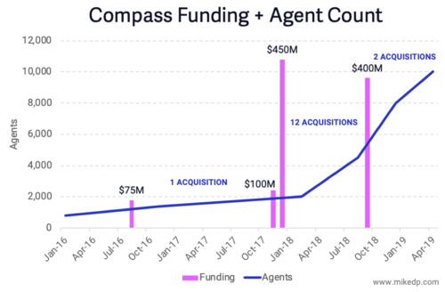

**Press**

1. Mike DelPrete talks about the sustainability of Compass and its inner workings ([Full PDF](https://static1.squarespace.com/static/57b1c75aebbd1abcdecf8171/t/5d37c1446e2436000137cd69/1563935051336/Inside-Compass-Strategic-Analysis.pdf))
2. Comparing Redfin, Compass and Purplebricks ([Seeking Alpha](https://seekingalpha.com/article/4158001-comparing-redfin-compass-and-purplebricks-who-wins))
3. The definitive guide to the Compass C-Suite ([The Real Deal](https://therealdeal.com/issues_articles/the-definitive-guide-to-the-compass-c-suite/) – Subscription Required)
4. Compass acquired Seattle proptech startup Modus ([Real Estate Weekly](https://rew-online.com/compass-acquires-title-escrow-startup-modus/) – Subscription Required)
5. How Compass Became the Bane of Real Estate ([Marker](https://marker.medium.com/how-compass-became-the-bane-of-real-estate-dc3738641b57))
6. Compass expands to Hawaii ([The Real Deal](https://therealdeal.com/2020/10/26/aloha-compass-brokerage-expands-to-hawaii/) – Subscription Required)
7. Compass make good on diversity pledge, adding Charles Phillips to board ([The Real Deal](https://therealdeal.com/2020/09/29/compass-makes-good-on-diversity-pledge-adding-charles-phillips-to-board/) – Subscription Required)
8. Cash, no stock: COmpass aims to cut down any Avid Dorfman windfall ([The Real Deal](https://therealdeal.com/2020/09/15/compass-aims-to-curb-an-avi-dorfman-windfall/) – Subscription Required)
9. Compass debuts AI tool to advise on home renovations ([The Real Deal](https://therealdeal.com/2020/07/08/compass-debuts-ai-tool-to-advise-on-home-renovations/) – Subscription Required)
10. Compass’ hunt for a securities attorney reignites talk of IPO ([The Real Deal](https://therealdeal.com/2020/06/17/compass-hunt-for-a-securities-attorney-reignites-talk-of-ipo/) – Subscription Required)
11. Seeking “a seat at the table,” Compass’ Aaron Seawood jumps to Triplemint ([The Real Deal](https://therealdeal.com/2020/06/12/seeking-a-seat-at-the-table-compass-aaron-seawood-jumps-to-triplemint/) – Subscription Required)
12. Compass’ chief people officer is out ([The Real Deal](https://therealdeal.com/2020/05/20/compass-chief-people-officer-is-out/) – Subscription Required)
13. Compass faces a reckoning ([The Real Deal](https://therealdeal.com/issues_articles/compass-faces-a-reckoning/) – Subscription Required)
14. Compass is going to trial in Avi Dorfman case ([The Real Deal](https://therealdeal.com/2020/02/20/compass-is-going-to-trial-in-avi-dorfman-case/) – Subscription Required)
15. Compass co-founder Ori Allon gets into the movie business ([The Real Deal](https://therealdeal.com/2020/02/05/compass-co-founder-ori-allon-gets-into-the-movie-business/) – Subscription Required)
16. Compass to lay off marketing, IT and M&A staffers ([The Real Dea](https://therealdeal.com/2020/01/27/compass-to-lay-off-marketing-it-and-ma-staffers/) – Subscription Required)